

KWAME NKRUMAH UNIVERSITY OF SCIENCE AND TECHNOLOGY

COLLEGE OF ENGINEERING

DEPARTMENT OF CHEMICAL ENGINEERING

TITLE: ESTIMATION OF CHLORINE WITH AgNO₃ (MOHR’S METHOD)

NAME: AMPAW-ASIEDU,MERCY

COURSE: BSC. CHEMICAL ENGINEERING

YEAR: SECOND YEAR

EXPERIMENT NO. : A.1.2.3.

I.D. NO: 3643609

T.A.: ASANTE NNURO WILLIAM
DATE: 9TH FEBRUARY, 2011.

Aims and Objectives:

- To determine the percentage of chlorine in a sample with AgNO₃.

INTRODUCTION

CHEMICALS AND EQUIPMENT

- AgNO₃.
- Potassium chromate as indicator
- 250ml volumetric flask.
- Pipette.
- Burette.
- Retort stand.
- Conical flask.
- Electronic balance.
- Unknown sample.
- Measuring cylinder.

PROCEDURE
- A 0.1g of the unknown sample is weighed into a beaker. The weighed sample is dissolved with distilled water into a 250ml volumetric flask and topped to the mark.
- 50ml of the solution was pipette into a conical flask and 2ml of a 5% potassium chromate is added which turned the solution to yellow.
- This is titrated against the 0.1M AgNO₃ solution from the burette. A red precipitate signifies an end point.
- Procedure 2 and 3 is repeated for concordant values of the endpoint.

TABLE OF VALUES

Burette Reading/cm³ | 1 | 2 | 3
Final | 10.40 | 20.90 | 31.50
Initial | 0.00 | 10.40 | 20.90
Titre value | 10.40 | 10.50 | 10.60

CALCULATIONS
Reactions:
Ag⁺ + Cl⁻ 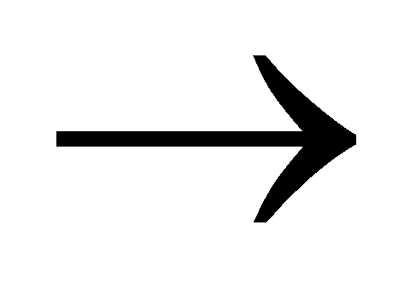AgCl (white ppt)

2Ag⁺ + CrO⁴⁻ Ag₂ CrO₄

_{mass of unknown = 0.1g}
_{concentration of} AgNO₃ = 0.1M

First titre value
volume = 10.40cm³

n (AgNO₃ ) =[AgNO₃ ]xV(AgNO₃)
= 0.1 x 10.40
1000
= 0.00104mol
n(Ag_{i}) = n(Ag_{ii})
2
= 0.00104
2
= 5.20x10⁻⁴mol
n(Ag_{i}) = n(Cl⁻)
= 5.20x10⁻⁴mol
m(Cl⁻) = n x M
= 5.20x10⁻⁴ x 35.5
= 0.0184g

Second titre value
volume = 10.50cm³

n (AgNO₃ ) =[AgNO₃ ]xV(AgNO₃)
= 0.1 x 10.50
1000
= 0.00105mol
n(Ag_{i}) = n(Ag_{ii})
2
= 0.00105
2
= 5.25x10⁻⁴mol
n(Ag_{i}) = n(Cl⁻)
= 5.25x10⁻⁴mol
m(Cl⁻) = n x M
= 5.25x10⁻⁴ x 35.5
= 0.0186g

Third titre value
volume = 10.60cm³

n (AgNO₃ ) =[AgNO₃ ]xV(AgNO₃)
= 0.1 x 10.60
1000
= 0.00106mol
n(Ag_{i}) = n(Ag_{ii})
2
= 0.00106
2
= 5.30x10⁻⁴mol
n(Ag_{i}) = n(Cl⁻)
= 5.30x10⁻⁴mol
m(Cl⁻) = n x M
= 5.30x10⁻⁴ x 35.5
= 0.0188g

Average titre = 10.40+10.50+10.60
3

Mean value = 0.0184+0.0186+0.0188
3
= 0.0186g

Percentage of Cl₂ in sample = mass of (Cl⁻) x 100%
mass of sample

= 0.0186 x 100%
0.1

= 18.6%

DISCUSSION

CONCLUSION
In conclusion, our data was reproducible and very precise. It was realized that 18.6% of chloride was in that sample. This is an effective way of determining chloride in a sample. This is a cheaper and faster. No major sources of error were presented in this lab.

PRECAUTIONS
• All apparatus was rinsed with distilled before use.
• The mass of the unknown was accurately weighed.
• The burette readings were taken from below the meniscus.

SOURCES OF ERRORS

- The effervescence did not entirely dissolve in the HCl before proceeding the experiment
- Too much of the indicator can affect the result of the reading

REFERENCES
General Chemistry by Whitten D. Peck
Vogel’s Textbook of Quantitative Analysis
Essential Chemistry by Raymond Chang
Lab. manual

